Access Changes Everything

Business Online Accessibility for People with Disabilities in Manitoba Survey Report

Date: May 1, 2023
By: Lisa Snider, Access Changes Everything (ACE)
Contact Email: web@accesschangeseverything.com
Contact Phone: (204) 430-5180
Table of Contents
Thank You 2
Project Creator 2
Project Summary 2
Survey Promotion 3
Survey Results 3
Location 3
Disability Information 4
Respondent Type 7
Barriers Found 9
Impact of Barriers 13
What Is Being Done Well 16
Final Input 19
Gift Draw 22
Appendix A: More About Access Changes Everything 22
Copyright 23

Thank You
This project was made possible by funding from the Manitoba Accessibility Fund (MAF). Access Changes Everything thanks the Province of Manitoba for their support of this project. As well, thank you to the survey respondents, and the Winnipeg Chamber of Commerce’s CODE (Commitment to Opportunity, Diversity and Equity) initiative, for their vital support role.

Project Creator
Lisa Snider from Access Changes Everything (ACE) created this project. More information can be found in Appendix A: More About Access Changes Everything.

Project Summary
Almost 25% of Manitobans, over the age of 15, identify as having at least one disability (Canadian Survey on Disability, 2017, Statistics Canada). It is vital that business online digital materials and media be made more accessible, for Manitobans with different disabilities.

Lisa Snider, from Access Changes Everything, conducted a survey, Business Online Accessibility for People with Disabilities in Manitoba, from December 2022 to January 2023. This ‘First Voice’ survey asked Manitobans with disabilities, and organizations or individuals who support us, to share lived experiences with online interactions, with Manitoba businesses.

The survey charted the overall accessibility of Manitoba businesses online, in terms of what businesses did well, and what needed improvement. The survey results were used to form the ‘Quick Start Guide to Digital Accessibility for Manitoba Businesses’, offered for free to Winnipeg Chamber of Commerce members.

The goal of the guide is to help businesses in Manitoba start to identify, and lower, barriers in the digital realm. It will also support compliance with the Accessibility for Manitobans Act, Customer Service and Accessible Information and Communication Standards.

Full access to Manitoba businesses online, without barriers, is crucial. With more awareness of lived experiences, and knowledge of how to lower barriers, Manitoba businesses can become accessible for all.

Survey Promotion
The survey was promoted through 169 emails, from December 2022 to January 2023. These were sent to individuals, businesses, organizations, and government departments, all over Manitoba.
The emails included the SurveyMonkey link, and a link to the project webpage, https://www.accesschangeseverything.com/business-online-accessibility-for-people-with-disabilities-in-manitoba-survey/
There was an option of entering a draw for a limited supply of $10 gift cards, sent through email. Personal information provided by those who took this option, was removed, and deleted after use.
The survey results, and guide, were promoted by the Winnipeg Chamber of Commerce, through CODE, their ‘Commitment to Opportunity, Diversity and Equity’ initiative. More information about CODE is located at https://winnipeg-chamber.com/code/

Survey Results

Location

Survey respondents were asked a required question, ‘Where do you live?’. The majority of the 37 respondents, 60%, were from the Winnipeg area. After that, 19% were from the Eastern part of the province, 14% were from the Southern part, 5% were from the Western part, and 2% were from the Northern part of the province. An option of ‘I prefer not to say’ was not chosen by any respondent.

The exact breakdown of locations and respondents is:

- 1 person was from Northern (Churchill, Thompson, The Pas, Moose Lake, Flin Flon, Lac Brochet, Gillam, etc.)
- 2 people were from Western (Killarney, Melita, Swan River, Virden, Souris, Brandon, Minnedosa, Neepawa, Shoal Lake, Dauphin, Swan River, Pelican Rapids, etc.)
- 7 people were from Eastern (Berens River, Gypsumville, Selkirk, Stonewall, Warren, Oakbank, Lac du Bonnet, Pinawa, Pine Falls, Hodgson, Whiteshell, Gimli, etc.
- 22 people were from Winnipeg (City of Winnipeg)
- 5 people were from Southern (Portage La Prairie, Carman, Niverville, Ste. Anne, Morris, Steinbach, Altona, Winkler, Morden, etc.)
Chart 1: Location
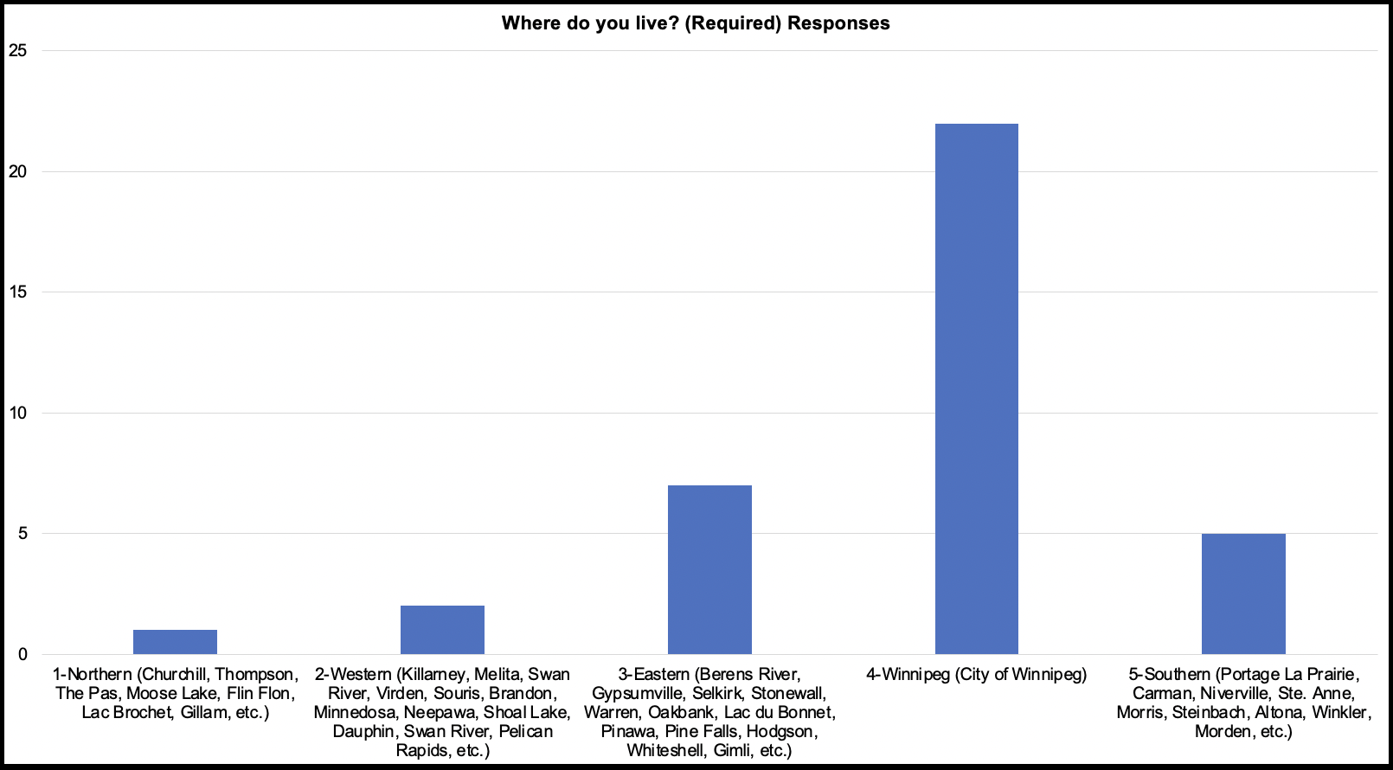

Disability Information

Survey respondents were asked a required question, ‘Do you identify as having a disability, or disabilities?”. Out of the 37 survey respondents, just over 51% identified with having at least one disability. The other 49% of respondents did not identify as having a disability.

The exact breakdown of responses is:

- 19 people chose, yes, I identify as having a disability or disabilities.
- 18 people chose, no, I don’t identify as having a disability or disabilities.
Chart 2: Disability
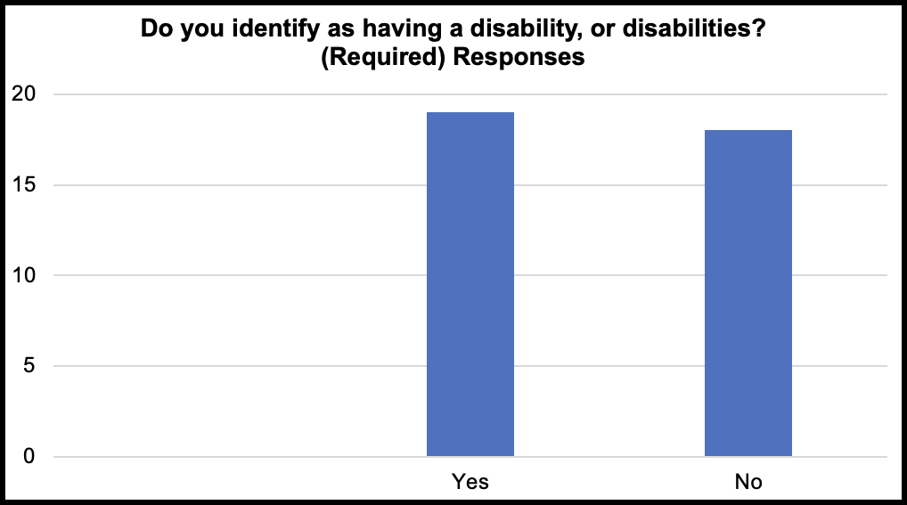
The 19 respondents who identified as having at least one disability were asked an optional question, ‘What types of disability, or disabilities, do you have?”. They could choose from six general disability types. Broad types were used, so that no one person could be identified in this public report. Two other choices were offered, ‘I prefer not to say’, and an area to write in disabilities. Respondents could choose more than one answer.

The exact breakdown of responses is:

- 5 chose Cognitive or Neurodiverse (Neurological, Learning, Intellectual)
- 2 chose Speech or Communication
- 9 chose Physical (Mobility, Pain, Flexibility)
- 6 chose Mental Health
- 4 chose Hearing
- 6 chose Visual

Chart 3: Disability Type or Types
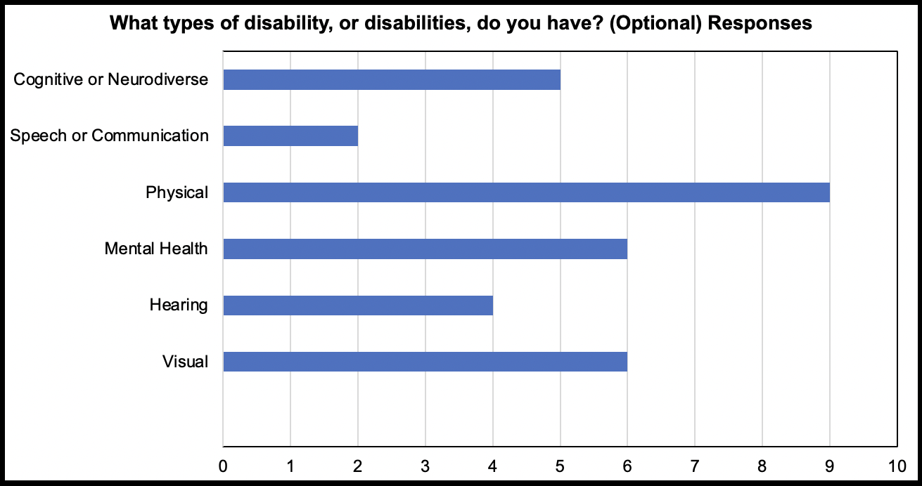

The most common disability type chosen by all 19 respondents was Physical. This was followed by Mental Health, Visual, and then Cognitive or Neurodiverse. No one chose ‘I prefer not to say’, and one person noted Gastrointestinal in the ‘other’ area.

Just over half, or 53%, of the 19 people who identified with having a disability, or disabilities, chose multiple disability types. The other 47% identified as having only one disability type.
The exact breakdown of responses is:

- 10 people chose multiple disability types.
- 9 people chose one disability type.

Chart 4: Multiple Versus Single Disability Types
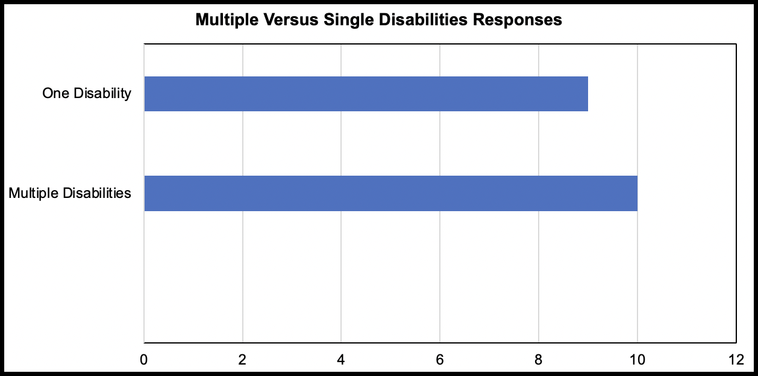

This is the list of multiple disability types chosen by 10 respondents:

- Hearing and Mental Health
- Physical (Mobility, Pain, Flexibility), Cognitive or Neurodiverse (Neurological, Learning, Intellectual), and gastrointestinal
- Visual and Hearing
- Physical (Mobility, Pain, Flexibility) and Speech or Communication
- Visual and Mental Health and Physical (Mobility, Pain, Flexibility)
- Hearing and Physical (Mobility, Pain, Flexibility)
- Mental Health, Physical (Mobility, Pain, Flexibility), and Cognitive or Neurodiverse (Neurological, Learning, Intellectual)
- Mental Health and Cognitive or Neurodiverse (Neurological, Learning, Intellectual)
- Mental Health and Physical (Mobility, Pain, Flexibility)
- Visual and Physical (Mobility, Pain, Flexibility), Speech or Communication, and Cognitive or Neurodiverse (Neurological, Learning, Intellectual)

This is the list of single disability types chosen by 9 respondents:

- Cognitive or Neurodiverse (Neurological, Learning, Intellectual)
- Physical (Mobility, Pain, Flexibility)
- Physical (Mobility, Pain, Flexibility)
- Physical (Mobility, Pain, Flexibility)
- Hearing
- Visual
- Visual
- Physical (Mobility, Pain, Flexibility)
- Visual

Respondent Type

Survey respondents were asked a required question, ‘Are you an organization, or individual, supporting people with disabilities in Manitoba?’. Out of 37 respondents, 73% were part of an organization, or were an individual, supporting Manitobans with disabilities.

The exact breakdown of responses is:

- 27 people chose yes, I am an organization or individual supporting Manitobans with disabilities.
- 10 people chose no, I am not an organization or individual supporting Manitobans with disabilities.

Chart 5: Organization or Individual Supporting People with Disabilities
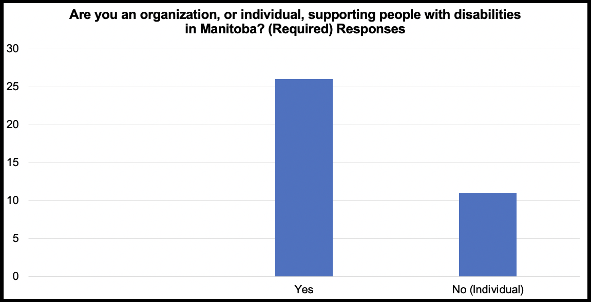

Out of the 27 respondents, who identified as an organization, or individual, supporting people with disabilities, 26 shared detailed information about their roles, and who they support. One respondent did not provide details. Some self-identifying information below has been generalized, to protect the respondent’s privacy.
The exact breakdown is:

- 6 people, or 23%, were program coordinators, supervisors and individuals who support people with disabilities in residential care homes, group homes, or similar entities.
- 6 people, or 23%, were working in human resources, or with employee and employment programs. Note that one person also ran their own disability services business.
- 4 people, or 15%, were supporting family members with disabilities.
- 4 people, or 15%, were working in post-secondary or other educational environments.
- 2 people, or 8%, were community seniors’ program members.
- 2 people, or 8%, were association or organization executive directors.
- 1 person, or 4%, was on a disability organization board of directors, and was part of an employee disability group.
- 1 person, or 4%, was working with accessibility in the Manitoba government.

Chart 6: Details About Roles and Who Is Supported
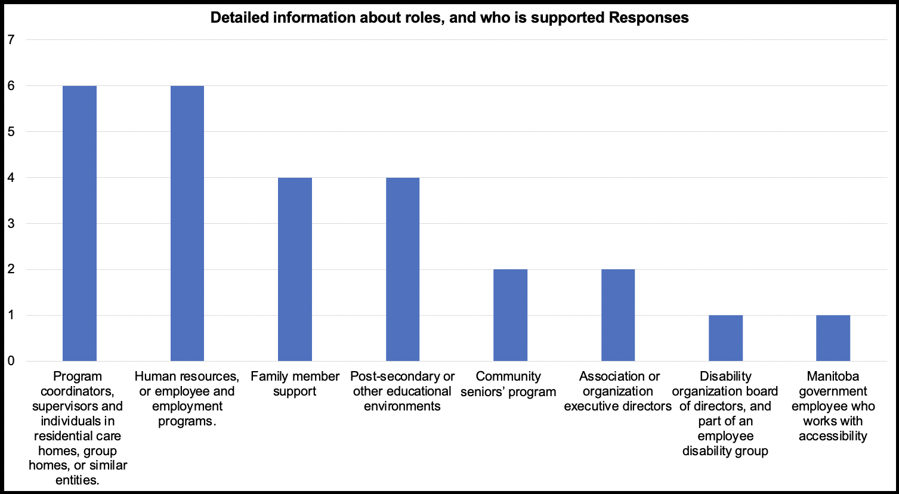

The largest percentage of the 27 respondents, at 23% each, were those who supported people with disabilities in residential care homes, group homes, or similar entities, and those working in human resources, or with employee and employment programs.

Then, at 15% each, were those who supported family members with disabilities, and those who worked in post-secondary, or other educational environments. The rest of the respondents worked in senior’s programs, organizations, and the Manitoba government.

Barriers Found

The first open ended optional question in the survey was, “What kind of barriers have you, or the people you support, found with Manitoba businesses online?”. The answers were analyzed, and then placed in one of four categories:

- General Barriers
- Website, Video, Social Media, and Document Barriers
- Human Support and Other Option Barriers
- Information in Advance Barriers
Most respondents noted general, or specific, barriers in websites, video, social media, and documents. The most common barriers were:

- Missing video captions
- No alternative text for images
- Colour contrast barriers
- Font size and text barriers
- PDF and online form barriers
- Information that is hard to find
- Navigation that is not clear

Many respondents felt that businesses should provide both online and offline ways to contact them, buy items or services, etc. This included a communication option of using sign language.

Respondents were very clear that human support was critical to access. Awareness of accessibility and disability, when communicating with customers and providing support, was essential. Otherwise, additional barriers could be encountered in the communication process itself.

Respondents shared that human support was vital when major barriers were found, and because many people with disabilities cannot afford, or lack access to, Wi-Fi, computers, devices with data, etc. Plus, it was clearly noted that some people are not knowledgeable about technology or the internet, so offline human support was crucial.

Finally, some respondents felt that physical space accessibility information was not provided in advance in the online realm. Respondents noted that information for physical spaces was crucial for confirmed access.

Some of the following responses could go under more than one category, and were edited only for obvious typos, missing commas and words, and misspelling. Out of the 37 respondents, four people did not answer this question.

General Barriers
- Access
- It is not always accessible.

Website, Video, Social Media, and Document Barriers
- There is a lag in the video playback.
- No clear Accessibility Page for accommodations. 2. websites are very busy and information about services, products and contact info is usually not clearly laid out. 3. sometimes videos don't have captions. I don't have a hearing disability but usually want to watch videos without the sound to avoid interrupting others (I don't like wearing headphones)

- The main problem I have had is when businesses use photos to convey information. My accessibility software does not always recognize the text in such images. Or if there is a video, and there is no sound, so you don't know what is going on.

- Sometimes websites of small businesses are built by people who do not know about accessibility. For example, no alt text, nonstandard controls, or graphical things that are easy to set up and click but not accessible.

- Some businesses seem very aware of accessibility issues such as alt text, and others have no clue - small and medium size businesses alike. Also, as a neurodivergent individual, I sometimes have difficulty understanding social media posts from businesses that have not been proofed/spellchecked because the number of spelling and grammatical errors cloud the meaning of what a business is trying to say. I’ve also noticed a number of smaller businesses/farmer's market types are not supportive of immunocompromised people when it comes to things like covid/vaccinations and that information is posted online.

- I have a visual impairment, I can't tell colors apart, and I need help choosing some important things.

- Web pages that are difficult to navigate, don't transfer information well between desktop and mobile versions, incompatible with screen reading technology or confusing with screen reading tech (e.g., can read the content, but reads it in a non-logical sense/order), color contrasts that are not in-line with WCAG, links that say, "click here".

- Not providing fonts or visuals that are accommodating. Needing to have credit cards to access resources online - which for many is not accessible.

- Website not accessible, because will not zoom, if zoomed, page moves and is not readable.
- Too much text.
- Size of print, ease of opening documents.

- Website print, unable to sign forms on PDFs, forms sent online to sign.

- PDF forms can be very small when using a mobile device.

- I am 87 years of age my dexterity is not as sharp as a 20 or 30 year old, especially when using the computer on banking, filling out forms, [and] on line purchasing, if you hesitate too long the systems are designed to perceive you as a threat and you find yourself locked out of the system.

- Not always accessible via screen reader, pathway to get information is not clear.

- Too complex, too lengthy, no instructions, nothing in plain language, people don't own devices, people cannot go on social media due to vulnerability traits (trolls).

- Difficulty finding information. Lack of clarity of information. Navigation issues. Lack of accessibility features.

- I have heard that websites are not accessible to those using a screen reader.

Human Support and Other Option Barriers
- Difficult to navigate, Confusing/Doesn't use plain language. Lack of resources to access i.e., Computer, phone with data, access to Wi-Fi. No person or phone number to defer to if having difficulty with information provided.
- For many of our clients, having to deal with services and questions online is very difficult. Many have no access to computers, may not know how to operate them and have a problem with not talking to a person one on one.

- Primarily the exclusive nature of online business is the fact that some people cannot afford current technology to do this, or that there is no option to do it the old fashion way of person-to-person communication without the use of 'online' tech.
- Inadequate or non-existent facilities and personnel to assist with online banking services. Such as opening an account.

- Barriers that people have found with Manitoba businesses online include difficulty navigating websites, lack of access to information, difficulty understanding the terms and conditions, and difficulty with online payment systems. Additionally, many Manitoba businesses do not have an online presence or are not equipped with the necessary technology to provide an effective online experience. This can create a barrier for those who are not tech-savvy or have limited access to the internet.

- Sometimes it not easy access what I want. I find the people on chat are not patient in helping me. They end the chat.

- Refusal to provide interpreters, refusal to provide captions. many businesses still only have phone lines instead of email access which often ends up with them hanging up on my interpreters or refusing to discuss any details.
- They have no ‘everything’ access for ASL / English Interpreter, as limit is not daily, as I want to anytime. And limit of Interpreter's fees as very high costs as I can't ably pay for it. Outside as my personal can’t afford pay for the interpreters.

Information in Advance Barriers
- Not a lot of information if places are accessible for wheelchairs or other walking aids.

- No to little information detailed to those with disabilities that they can use, or be able to take part in and/or to access that is designed for them.
- It is often difficult to find out ahead of time if places have seating for someone with a disability, example Jets game.
- Inaccessibility of some physical locations, individuals unwilling to interact with the individual who uses mobility aids.

Impact of Barriers

The second open ended optional question in the survey was, “How did the barriers impact you, or the people you support?”. The answers were analyzed, and then placed in one of these four categories:

- General Impact
- Frustration, Anxiety, and Time Consuming Impact
- Being Left Out, Left Behind or Excluded Impact
- Reliance on Others and Independence Impact

Most respondents noted that barriers could be frustrating, increase anxiety, cause disengagement, and be time consuming. Many felt that barriers could also lead to a loss of independence, increased reliance on others, and feeling of being left out, left behind, and excluded from society.

Other respondents noted that barriers can greatly impact a person’s mental health, and their sense of belonging and well-being. Plus, some clearly noted that barriers can cause lost opportunity, loss in income, and negatively impact financial status.

Overall, respondents made it very clear that barriers must be taken seriously, and removed as soon as possible. As well, it was clear in the responses that human support was crucial, when barriers blocked access.
Note that some responses could go under more than one category, and were edited only for obvious typos, missing commas and words, and misspelling. Out of the 37 respondents, six people did not answer this question.

General Impact
- No entry.

- Not able to access businesses in person.

- The process is complicated.

Frustration, Anxiety, and Time Consuming Impact
- Lost opportunities. Increased anxiety.
- I get very anxious when looking for information online due to my ADHD. My mind tends to jump around, and a busy, cluttered, unfocused website makes this much harder. I often leave that page and try to find what I want on another page. I will not bother watching videos if they do not have captions.
- Cause excess frustration for the individual I support, which impacts their mental health and overall well-being.
- It creates frustration and can take days for correction.
- Was not able to use and very frustrating.
- It is frustrating and will cause me to look somewhere else for what I am looking for.
- Too much text causes individuals to become disengaged with the content.
- Very difficult, to which I more or less didn't end up using the service and/or information that was provide to me.
- The barriers impacted me and the people I support in a variety of ways. The most immediate and direct impact was the financial strain caused by the loss of income due to the inability to work. This had a ripple effect, causing people to struggle to pay for basic necessities, such as food and rent. Additionally, the barriers caused stress, anxiety, and fear as people were uncertain of the future and how they were going to make ends meet. The barriers also created a sense of isolation, as people were unable to engage in activities outside of their homes.

- Increases time to navigate and use website, or find required information, increases frustration, sometimes to the point of not being able to find the information needed, sometimes completely inaccessible.
- We always have to cancel appointments because we are not being accommodated.
- Very challenging for our clients.

Being Left Out, Left Behind or Excluded Impact
- Technology does become a barrier and without non-tech options, then the situation excludes some people with disabilities. In those situations, then someone else must 'stand-in' for the person rather than being independent. It is no different than the situation of a single step at the front of the corner grocery store. Sadly, governments are moving to this exclusionary technology for more and more public services.

- Lack of understanding, knowledge, life skills, social skills, norms, current events, pursuing interests, achieving goals, employment, volunteer, social roles, community events.
- Unable to enjoy financial services and not included in a growing technology-driven society.
- They could not benefit from the information, products, or services of that website.
- Yes, I have experience of my situation as my second languages of barriers as I don’t understand as I want to get American Sign Language access as example Video Relay Interpreter is not provided this time.
- Can't access information. Can't complete business. Can't make purchases.
- Lack of service, and possible financial, physical, or legal damages if I didn't understand what I was agreeing to. Lack of clarity in information if there are videos or podcasts but no captions/transcripts.
- Generally, I try to find another business to support - one that is more open, accommodating, and consistent with their online presence and in-person experiences. while I don't personally need it, I find things like alt text descriptions helpful as well.

Reliance on Others and Independence Impact
- They've needed to rely on family or friends to make purchases and then pay them back. Which is a big ask depending on what it is their looking to do, it also requires permission and does not support full dignity or independence.
- I need help from others.
- They cannot read all of the content. They also cannot complete a task independently and it can take them much longer when the information is not clear or the direction to get the information.
- Will have to go in person to sign forms, or for help and assistance rather through the convenience of doing it at home on a phone, tablet, or computer.
- Had to go early and find someone to talk to, was very difficult.

- I would need to email the business and ask for information or get help placing an order or finding info.
- On the chat people are not patient and end the chat.

What Is Being Done Well

The third open ended optional question in the survey was, “What was done well by Manitoba businesses online? How did that help you, or the people you support?”. The answers were analyzed, and then placed in one of these six categories:

- General Done Well
- Website, Video, and Social Media Accessibility Done Well
- ‘Human’ Support Done Well
- Awareness Done Well
- Information and Communication Options Done Well
- Nothing Done Well

While only two respondents felt there was nothing being done well, and 14 people did not answer the question, the other 21 respondents did offer their views on what is being done well. Note that some responses could go under more than one category, and were edited only for obvious typos, missing commas and words, and misspelling.

Most respondents noted improvements in, and increased awareness of, website, video, and social media accessibility. Some business websites provided:

- Described images
- Good colour contrast
- Easy to read flexible sized text
- Consistent layout and design on different devices
- Navigation that was easy to use
- Video and audio captioning

Some respondents noted that social media posts did well with alternative text for images, video captioning, informative content, and advocating for accessibility. Other respondents highlighted accessibility information that is clearly noted, and businesses promoting their local location.

Many respondents noted that ‘human’ support was crucial to accessing businesses in Manitoba. However, it was the awareness and understand of different needs, including the need to provide sign language interpretation, that was key to successful support interactions.

Others noted that presenting information in diverse ways was also very important for access. Overall, it was clear that people with disabilities would come back to a business, if the digital realm was made more accessible, and informed human support was provided.

General Done Well
- Much business can be done online- bill paying, purchases made, etc. this is very helpful, fewer physical errands needed.

- Problems can be solved in time, I can rest assured shopping online.

Website, Video, and Social Media Accessibility Done Well
- Read aloud tech built right into the webpage (this one is huge! to not have to test/ensure that other screen reading tech works with every website update), limited lengthy text/broke text into sections or separate webpages (easier to read and navigate), used color themes with contrasts that followed WCAG, ensured layout/design was consistent across desktop and mobile versions (allowing for easier access for those regularly using both devices), allowed for web extensions to fully access content (e.g. web extensions to change font - not including text as a part of images).
- Some businesses have very accessible websites, and I was able to find info and place orders online.

- Many businesses are trying to improve how they share info online. I am finding that there are more with described images on their website, so I am not having to guess what is going on. I am starting to find also that some are working at making their sites less cluttered, which makes them easier to navigate.
- Some businesses list their location, so we know it is a local business, rather than making us search the whole website or send a question through 'contact us' to find out. People with disabilities need to plan. A page of information About Us that is written in plain language with very little formatting and images, and states what they do or sell and how to contact them to buy is very delightful when you come across it.
- Some have parking and seating on their websites, makes attending easy and fun.
- Some are starting to be more consistent with captioning video or audio content, some are becoming more accessible with having multiple points of contact. A few have started having an accessibility widget to adjust the viewing experience as well.
- Some businesses are great with inclusivity in their social media - they include alt text and advocate as safe spaces in their online presence as well as in person services.

- Social media posts that have closed captioning built into videos.

- Social media posts are informative.

‘Human’ Support Done Well
- Some businesses will reply to emails, when asked for a person to speak to directly, and have explained, and helped navigate or assigned a person to talk to.
- Good support by businesses that sell goods to me, poor support from the banking service.
- There are some salespeople on chat that are patient and understanding with my disability.
- This depends on the situation, as what I need, received from Reaching Equal Employment Service and Calvary Temple Church, as they provided American Sign Language interpreter on the Online, as they help me through it. The people support is awesome.

Awareness Done Well
- Understanding of disabilities and how to deal with the person.
- We have experienced some small businesses that once they were aware of the barriers they had created online, they did take the time and took extraordinary steps to accommodate the individual. But it took us explaining the situation, but the final result was a one-up solution. Hopefully these businesses have learned something they can implement with their online presence.

Information and Communication Options Done Well
- Diverse ways of presenting information.
- Some businesses have multiple modes to receive information.

Nothing Done Well
- No changes to these resources have been made at this time.
- Nothing, and no plans of making improvements and/or adjustments to their outline.

Final Input

The fourth, and last, open ended optional question in the survey was, “Anything else you want to share about getting information, or buying things, online with businesses in Manitoba?”. The answers were analyzed, and then placed in one of four categories:

- General Awareness Final Input
- ‘Human’ Support Final Input
- Website, Video, and Social Media Accessibility Final Input
- Accessibility is Important Final Input

Note that some responses could go under more than one category, and were edited only for obvious typos, missing commas and words, and misspelling. Out of the 37 respondents, 21 people did not answer this question.

As in the other open ended question areas, website accessibility and sign language for videos were highlighted in the final input area. As well, ‘human’ support provided in a quick fashion, and general awareness of disability and digital accessibility, were vital for accessing businesses both online and offline.

Overall, respondents noted that digital accessibility, having online and offline options, and human support were crucial. Respondents wanted accessibility to be considered from the start, and for people with disabilities to be included. The final input was mostly hopeful, with a couple of respondents asking businesses to go further than the bare minimum, and embrace accessibility as ‘normal’, not an afterthought.

General Awareness Final Input
- Manitoba businesses in general are still very much in the early 2000s of business models with bare minimum of information online, and the expectation that you will call or physically come in rather than do business online.
- It is getting better. There has been improvement over the years. Hopefully it doesn't turn me into an online shopper addict.
- It would be great if Manitoba businesses got together to choose one online platform to use for selling products or services. The consistency would likely increase the returning rate of people with disabilities to those Manitoba businesses.
- To consider developing appropriate products and services working with agencies that support persons with disabilities.
- Being different from the majority is not helpful but this survey and previous efforts have not changed my life.
- Shopping is convenient.

‘Human’ Support Final Input
- All businesses should provide a name and number of the person or department that one can speak to if having difficulty navigating an online process. Businesses can offer an area/room where people can have free access to technology i.e., computer/printers if a requirement to place an order/receive a coupon or complete an application. This area should have a staff person on site to answer questions or help if there is an issue. (Same idea as self-checkouts with a staff available to assist and support).
- There should just be more people present to take our calls and our inquiry, that way we are not in a long queue.
- The unstated barrier that seems to go unnoticed with the wonderful convenience of online processes is that there is a complete loss of human contact which does have a cost; a cost that most Canadians have felt (maybe not recognized) in the past 3 years. Human contact is vital to a complete life.
- It's very frustrating to get help online.

Website, Video, and Social Media Accessibility Final Input
- Businesses should focus on their websites and making them accessible and up to date. Social media is nice for sharing the links but if the website hasn't been updated in months that is not helpful, even if it is accessible.
- I would like to see who [has] made video, as an access[ible] sign language vlog with businesses, and we will understand what they say about information or buying things. I have not seen any...

- I just wish it was more user friendly for those who may not have or own a smart phone, for example.

Accessibility is Important Final Input
- Please don't just do the bare minimum, accessibility needs are always changing and being open to, and embracing accessibility and designing for accessibility will help reduce the barriers some experience, and pave the way for accessibility as the "normal", not an after-thought.
- Most Manitoba businesses are doing quite well online, but a lot of them might benefit from knowing more about accessibility issues when starting up a business. I’m not sure how that can be done since every second person seems to have some sort of side hustle they refer to as a business, but if people are going to do that and take it seriously, and BE taken seriously, they need to know about being inclusive.

Gift Draw

Out of 37 survey respondents, 49% of respondents chose to apply for the gift card draw, while 51% declined to be part of the draw.

The exact breakdown is:

- 18 people chose to apply for the gift card.
- 19 people chose not to apply for the gift card.

Appendix A: More About Access Changes Everything
Lisa Snider is the Senior Digital Accessibility Consultant and Trainer in her company, Access Changes Everything (ACE). Lisa started Access Changes Everything in Winnipeg in 2016.

For over 20 years, Lisa’s passion in life has been making the digital world more accessible for people with disabilities, in different North American settings and contexts, as a web developer, archivist, librarian, and since 2016, as a senior accessibility consultant.
Lisa shares her knowledge with clients through digital accessibility training, courses, presentations, auditing with people with disabilities, remediation, and facilitation. Lisa has provided these services to a wide variety of North American organizations, governments, and businesses, such as the Government of Manitoba, Canadian Museum for Human Rights, City of Winnipeg, etc.
Lisa specializes in digital accessibility, which includes: websites, documents, audio, video, email, electronic signage, social media, apps, EPUB eBooks, etc. She is a nationally recognized digital accessibility advocate and specialist, an internationally recognized archival accessibility expert, and is a person with multiple disabilities.
Lisa Snider was Chair of the Province of Manitoba’s, Accessibility for Manitobans Act, Information and Communication Standard Development Committee. In 2022, she was an Associate in the Independent Nova Scotia Accessibility Act Review, and in 2023 was named Chair of the Nova Scotia Accessibility Act, Goods and Services Standard Development Committee. In 2022, she was also chosen to be a member of the Accessible Canada Act, Technical Committee on Accessibility Requirements for Information and Communication Technology Products and Services.
Lisa was a Stakeholder in the W3C Accessibility Guidelines Working Group Silver Task Force (WCAG 2.1), and is an invited member of the Microsoft Inclusive Workplace Customer Advisory Council, collaborating with Microsoft to improve the accessibility of their products.
More information about Access Changes Everything, and Lisa Snider, is available on the Access Changes Everything website, at http://www.accesschangeseverything.com/.

Copyright
© Copyright 2023 Access Changes Everything.

Unless otherwise expressly stated in writing, Access Changes Everything retains copyright, and all intellectual property rights, to all materials, and content in them, created by Access Changes Everything. Other formats are available upon request.

